MESCO TRUST · NEW WEBSITE
Website Testing Feedback
& Change Requests
Testing Round 2 — issues, change requests, new features and BRD gaps, with screenshots
Website | https://mesco-demo.aiolos.cloud/
Admin panel | https://mesco-demo.aiolos.cloud/admin
Document | Testing 2 — formatted and structured version
Prepared by | Muzaffar Shaikh, MESCO Trust
For | Website development team
Date | 17 October 2026
Contents | 33 feedback items, 23 BRD gap points and 8 additional findings

How to read this document
Every observation has an ID (for example WEB-03) so it can be discussed and tracked easily. Each item shows where the problem is, what the tester noted, what we expect, and space for the development team’s response. The tester’s original notes are kept word for word; the “Expected result” lines were added to make each request clear.
Code | Section | What it covers
WEB | 1. Public website | Problems visitors see on the website
DON | 2. Donation page | Donate page design, rules and donor features
ADM | 3. Admin panel | Problems and requests in the CMS used by MESCO staff
NEW | 4. New pages and features | Things to be added
UI | 5. Design, text and content | Formatting, wording, phone numbers, icons
BRD | 6. BRD gap list | Requirements from the BRD that are missing or incomplete

Labels used
Label | Meaning
Bug | Something is broken or does not work as it should
Change | Works, but needs to be changed as requested
Design / Content | Look, formatting or wording needs correcting
New feature | Something new to be built
Question | The development team needs to confirm how it works
High / Medium / Low | Suggested priority; MESCO may change these

Summary
Section | Items | Bug | Change | Design / Content | New feature | Question | High priority
1. Public website: issues found | 7 | 5 | 2 | 0 | 0 | 0 | 3
2. Donation page | 5 | 1 | 3 | 0 | 1 | 0 | 4
3. Admin panel | 5 | 2 | 2 | 0 | 0 | 1 | 3
4. New pages and features requested | 7 | 0 | 2 | 0 | 5 | 0 | 1
5. Design, text and content review | 9 | 1 | 0 | 8 | 0 | 0 | 1
Total | 33 | 9 | 9 | 8 | 6 | 1 | 12

All items at a glance
ID | Item | Type | Priority
WEB-01 | Loading animation stays on screen after closing the PDF viewer | Bug | High
WEB-02 | Study Centre menu item | Change | Medium
WEB-03 | Home page Image Gallery shows “No gallery images are available” | Bug | High
WEB-04 | Animations are not smooth on mobile | Bug | Medium
WEB-05 | Home slider video does not display properly on mobile | Bug | High
WEB-06 | Chatbot cuts long answers | Bug | Medium
WEB-07 | Annual Report thumbnails should be portrait | Change | Medium
DON-01 | Proposed donation box design | Change | High
DON-02 | One dropdown for all donation categories | Change | High
DON-03 | Selected scheme is not clear; add a summary (“cart”) on mobile | Bug | High
DON-04 | Non-Zakat (NZ) donations must follow the chosen scheme | Change | High
DON-05 | Donors can see their donation history after verification | New feature | Medium
ADM-01 | Back button in Sliders goes to the wrong page | Bug | Medium
ADM-02 | Home gallery section: manual choice or automatic latest images? | Question | Medium
ADM-03 | Changes to form fields do not appear on the website | Bug | High
ADM-04 | Admin panel is too complex to use | Change | High
ADM-05 | No deleting of records anywhere in the admin panel | Change | High
NEW-01 | Coffee Table Book page | New feature | Medium
NEW-02 | Membership button next to Volunteer | New feature | Medium
NEW-03 | Career form should show only the current opening (plus one other) | Change | Medium
NEW-04 | FAQ section | New feature | High
NEW-05 | Ex-Student Directory page in year-wise format | Change | Medium
NEW-06 | Event attendance confirmation (Yes / No / Maybe) | New feature | Low
NEW-07 | “Cause of the Month” pop-up | New feature | Low
UI-01 | MESCO logo is blurry and should be left-aligned | Design | Medium
UI-02 | Study Centre link does not work | Bug | High
UI-03 | Body text should be justified | Design | Low
UI-04 | Long paragraphs should be bulleted and easier to read | Design | Medium
UI-05 | Old Newspaper page is not well formatted | Design | Medium
UI-06 | Headings break onto two lines | Design | Low
UI-07 | Button text on the Donor Testimonials page | Content | Low
UI-08 | Phone numbers: format and consistency | Content | Medium
UI-09 | Mobile menu icon has 2 lines instead of 3 | Design | Low

1. Public website: issues found
Problems seen by visitors on the live demo site.
WEB-01 Loading animation stays on screen after closing the PDF viewer
Where: Home page → EX Student Directory 2025 (PDF pop-up) Type: Bug Priority: High Status: Open
Tester’s note | This Loading section don’t get away after we click cross after viewings the pdf.
Expected result | After the PDF pop-up is closed with the X button, the loading animation must disappear and the page must be usable again without a refresh.
Developer response

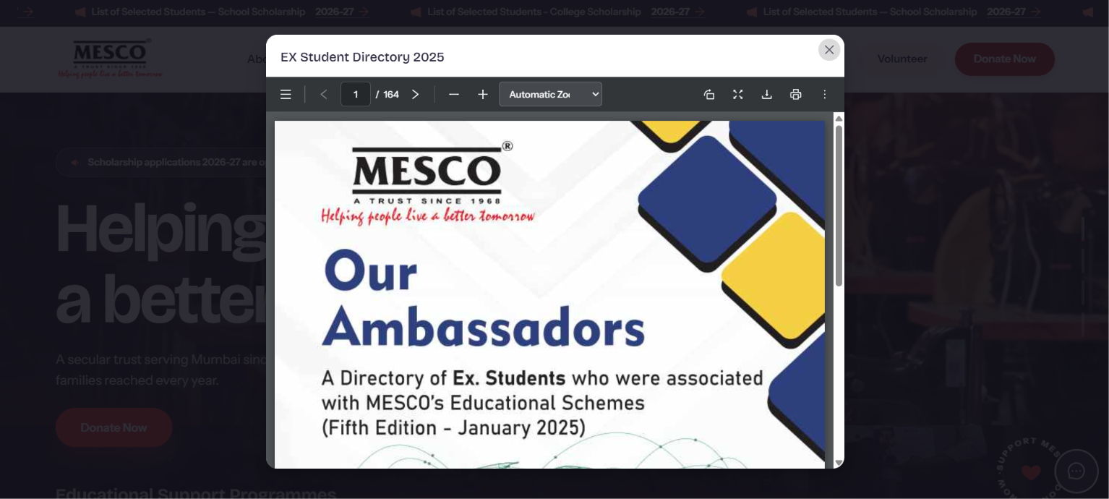
Figure 1: PDF opened in a pop-up (EX Student Directory 2025)
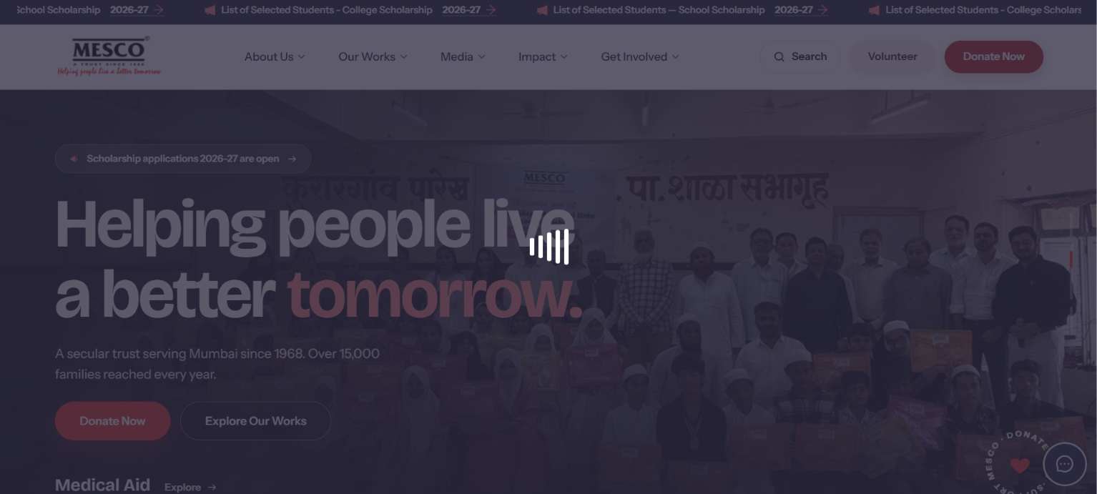
Figure 2: After clicking X, the loading animation stays over the page

WEB-02 Study Centre menu item
Where: Header menu → Our Works → Study Centre Type: Change Priority: Medium Status: Open
Tester’s note | One Study Centre page is also on our website only.
Expected result | Study Centre should open a Study Centre page on the new website. The current link goes to the old website, which does not open (see UI-02).
Developer response

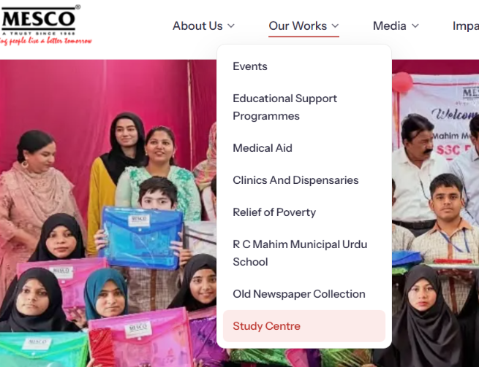
Figure 3: Our Works menu with the Study Centre item

WEB-03 Home page Image Gallery shows “No gallery images are available”
Where: Home page → Image Gallery (“Moments from the field”) Type: Bug Priority: High Status: Open
Tester’s note | Image Gallery: The gallery section displays “No gallery images are available” despite being present on the website. Please check the image fetching and display functionality.
Expected result | The home page gallery should show the latest gallery photos. The Image Gallery page already has 23 albums, so the home section should not be empty.
Developer response

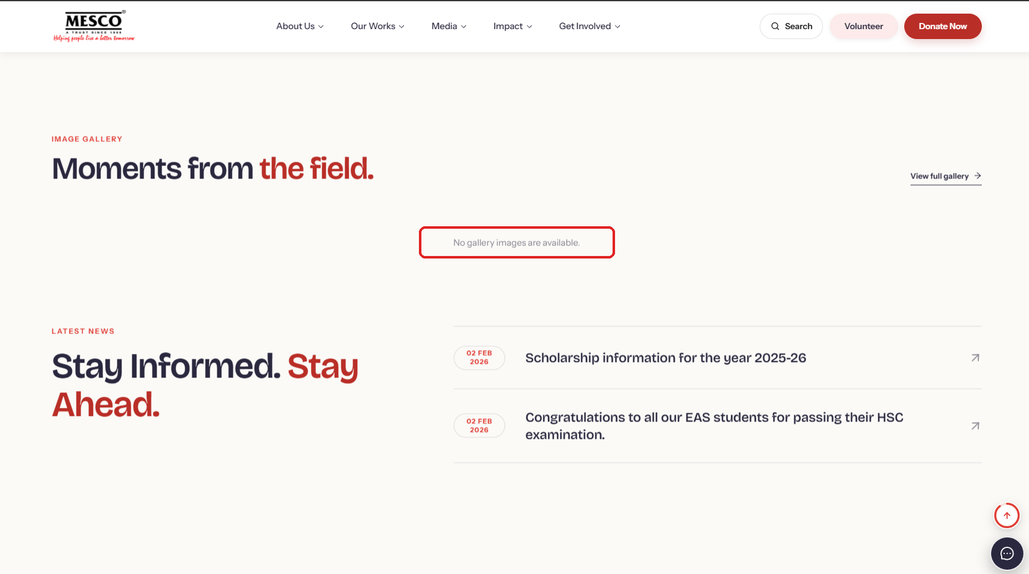
Figure 4: Home page gallery section shows “No gallery images are available”

WEB-04 Animations are not smooth on mobile
Where: Home page (mobile view) Type: Bug Priority: Medium Status: Open
Tester’s note | Mobile View – Animation Glitch: The animations in these two sections are not smooth on mobile devices. Please optimize the transitions for smoother performance and a better user experience.
Expected result | Section animations on mobile should be smooth with no jumping, flicker or blank areas while scrolling.
Developer response

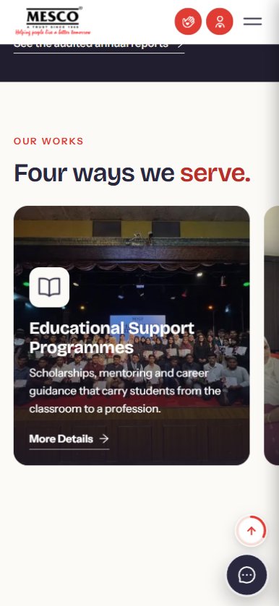 | 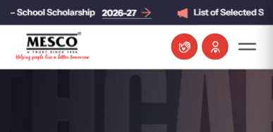
Figure 5: Mobile: “Four ways we serve” section | Figure 6: Mobile: header and banner area

WEB-05 Home slider video does not display properly on mobile
Where: Home page slider (mobile) + Admin → Sliders Type: Bug Priority: High Status: Open
Tester’s note | Home Slider – Mobile Video Upload: The home slider video is not displaying properly on mobile devices. Add a separate mobile video upload option in the Admin Panel to optimize the video for mobile view.
Expected result | The slider video should fit the mobile screen correctly. The admin panel should allow a separate mobile video for each slide (like the separate desktop/mobile images).
Developer response

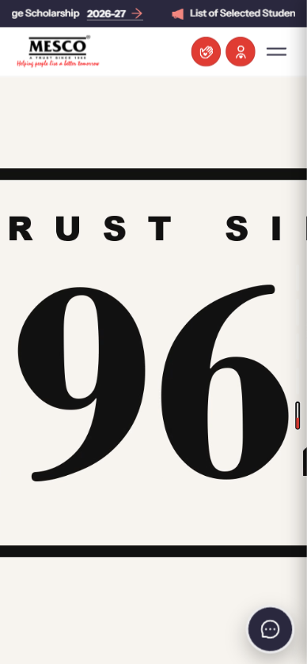
Figure 7: Mobile: slider video is cropped and does not fit the screen

WEB-06 Chatbot cuts long answers
Where: Chatbot (MESCO Help Desk) Type: Bug Priority: Medium Status: Open
Tester’s note (from the screenshot) | Chat Message: The long message is not displaying properly in the chat box. The text is getting cut and a scrollbar is appearing. Please adjust the chat box design so that the full message is visible without text cutting.
Expected result | Long chatbot answers should wrap inside the chat bubble and show in full, with no side scrollbar.
Additional observation | The test entry “hyperlink test” with dummy (lorem ipsum) text is visible to the public in the chatbot and should be removed.
Developer response

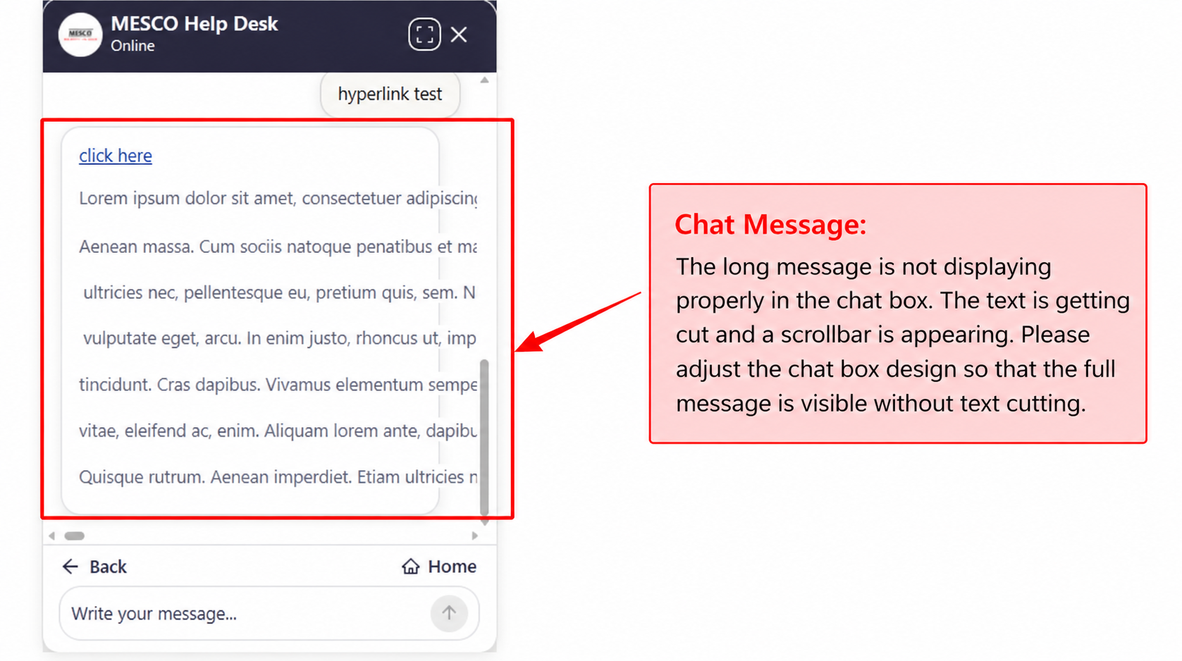
Figure 8: Chatbot answer text is cut, with a scrollbar

WEB-07 Annual Report thumbnails should be portrait
Where: Media → Annual Reports Type: Change Priority: Medium Status: Open
Tester’s note | The Annual Report thumbnail should be in portrait orientation, matching the dimensions of the Annual Report’s front cover.
Expected result | Each Annual Report card should show the front cover in portrait (book) shape, not cropped into landscape.
Developer response

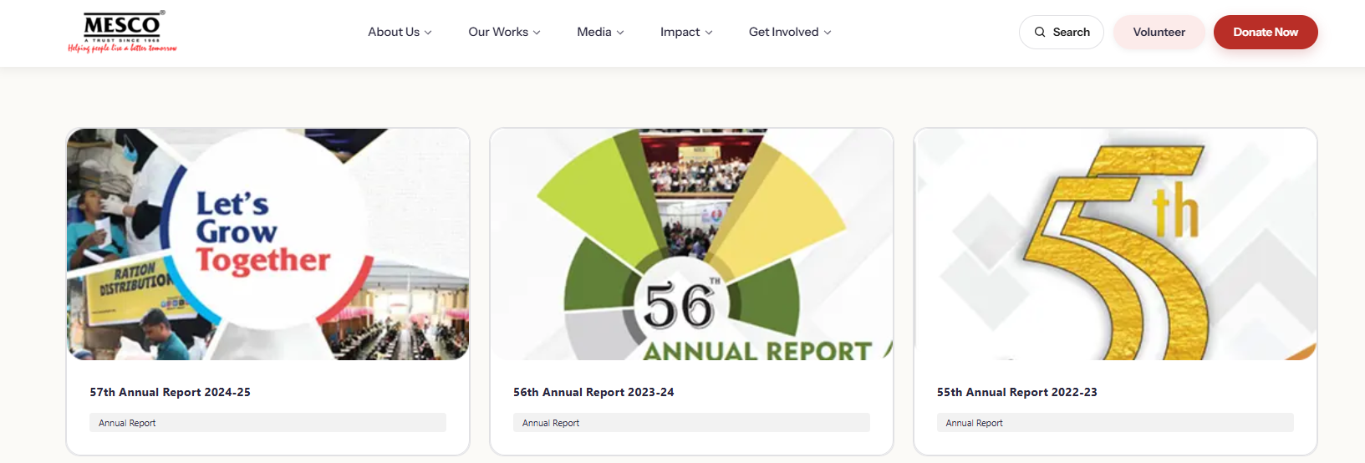
Figure 9: Annual Report cards currently use landscape crops of the covers

2. Donation page
Changes and fixes for the Donate page and donation handling.
DON-01 Proposed donation box design
Where: Donate page → scheme cards Type: Change Priority: High Status: Open
Tester’s note | As discussed in the meeting, this is the proposed design for the donation box functionality.
Expected result | Build the donation boxes as in the proposed design: each scheme card shows the amount, description and a quantity selector (− / +), and the selected cards are clearly highlighted.
Developer response

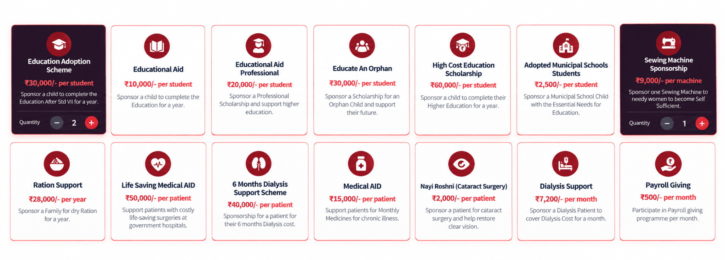
Figure 10: Proposed donation box design (scheme cards with quantity selector)

DON-02 One dropdown for all donation categories
Where: Donate page → Details Type: Change Priority: High Status: Open
Tester’s note | Donation Page – Single Dropdown Menu.  Combine all donation categories, including Zakat, Non-Zakat, Interest, and other donation types, into a single dropdown menu. Remove the separate buttons for each category and display all options within one dropdown button.
Expected result | Replace the separate category buttons and the separate Zakat / Interest Money fields with one dropdown listing all donation types (Zakat, Non-Zakat, Interest and others).
Developer response

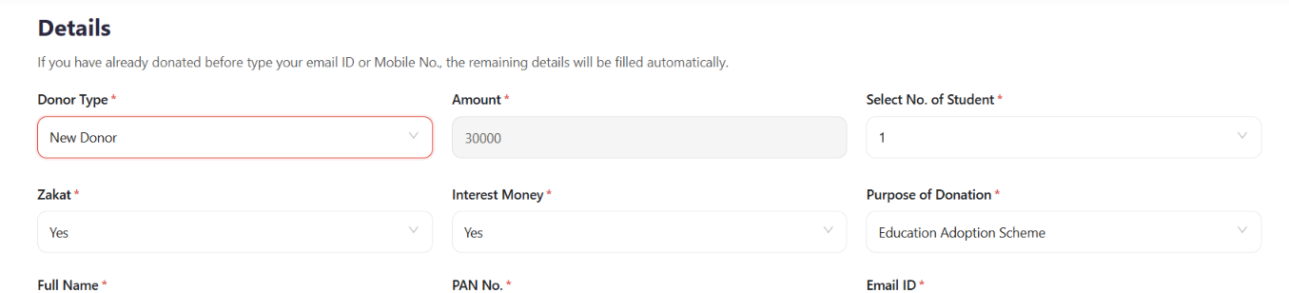
Figure 11: Current Details section with separate Zakat and Interest Money fields

DON-03 Selected scheme is not clear; add a summary (“cart”) on mobile
Where: Donate page → scheme cards (desktop and mobile) Type: Bug Priority: High Status: Open
Tester’s note | While hovering the scheme we cant be able to know which is selected ui change there is a ui breakdown also in mobile show something like a cart which will show how much and what amount is been selected and which scheme.
Expected result | 1) A selected scheme must look clearly different from a hovered one.  2) Fix the layout break on mobile.  3) On mobile, show a summary bar (like a cart) listing the selected schemes, quantities and the total amount.
Developer response

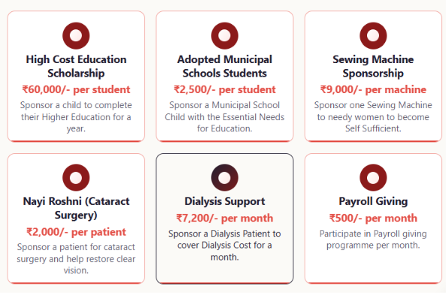
Figure 12: Hover and selected states look the same

DON-04 Non-Zakat (NZ) donations must follow the chosen scheme
Where: Donate page → allocation rules Type: Change Priority: High Status: Open
Tester’s note | Donation Allocation – Non-Zakat (NZ) Donations - Ensure that Non-Zakat (NZ) donations designated by the donor for the High Cost Educational Scheme (HCES) are allocated exclusively to HCES. The donation allocation must follow the specific scheme selected by the donor. like some of the schemes only use nonzakat so when someone select that scheme like hces then it will automatically select donation.
Expected result | Each donation is recorded against the exact scheme the donor selected. Schemes that accept only Non-Zakat money (e.g. HCES) automatically set the donation type to Non-Zakat when chosen.
Developer response

DON-05 Donors can see their donation history after verification
Where: Donate page / donor area Type: New feature Priority: Medium Status: Open
Tester’s note | Donors can see their donation history once they verify their details.
Expected result | After verifying their email or mobile number, a donor can view a list of past donations (date, amount, scheme). Related to BRD item 19 in Section 6.
Developer response

3. Admin panel
Issues and requests for the CMS used by MESCO staff.
ADM-01 Back button in Sliders goes to the wrong page
Where: Admin → Sliders → edit a slider Type: Bug Priority: Medium Status: Open
Tester’s note | Admin Panel – After editing any component in the Slider section and clicking Back, it redirects to a different page instead of returning to the Slider section.
Expected result | Clicking Back (←) after editing a slider returns to the Sliders list.
Developer response

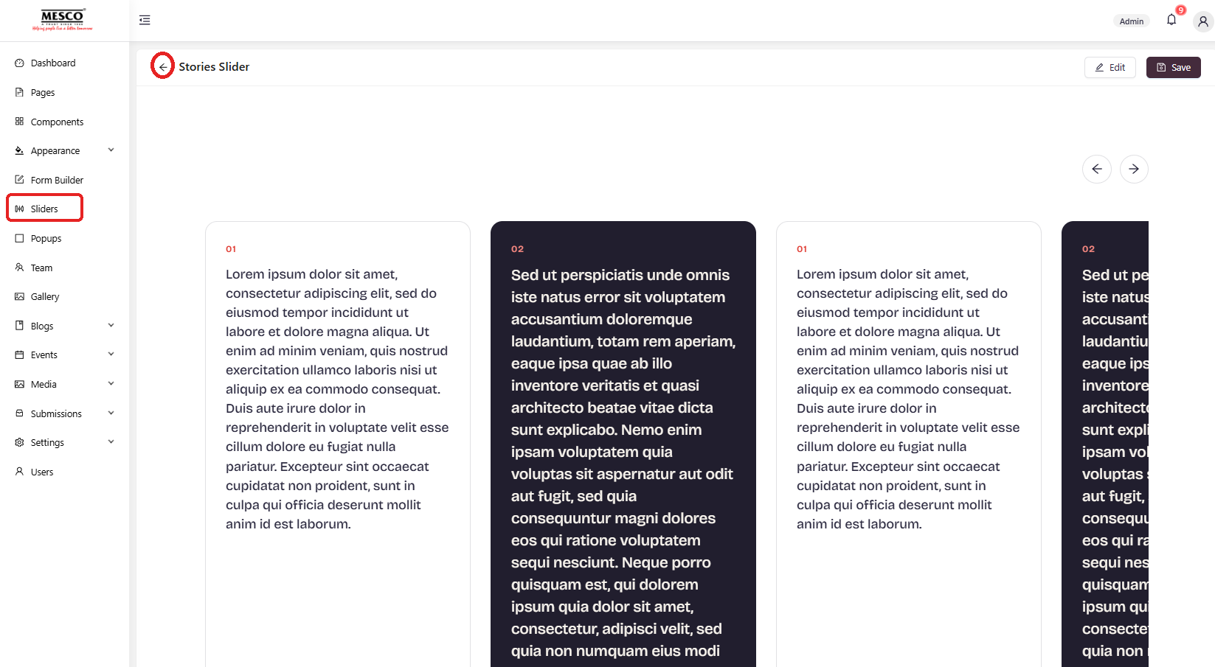
Figure 13: Stories Slider editor: the Back arrow does not return to Sliders

ADM-02 Home gallery section: manual choice or automatic latest images?
Where: Admin → Pages → Home → LatestImageGallery Type: Question Priority: Medium Status: Open
Tester’s note | Do we have an option to make the changes to this section or it will automatically takes latest images what we have upload at the gallery section / page.
Expected result | Development team to confirm how this section picks images. Preferred: it shows the latest gallery images automatically, with an option to choose images manually.
Developer response

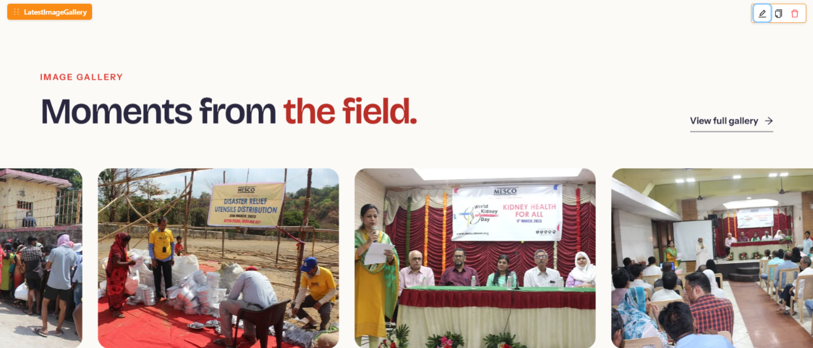
Figure 14: LatestImageGallery component in the page editor

ADM-03 Changes to form fields do not appear on the website
Where: Admin → Pages → Donate Now → form component Type: Bug Priority: High Status: Open
Tester’s note | We change the form of the form input but it doesn't change on the website.
Expected result | When form fields are changed in the admin panel and Update is clicked, the website form must show the change.
Developer response

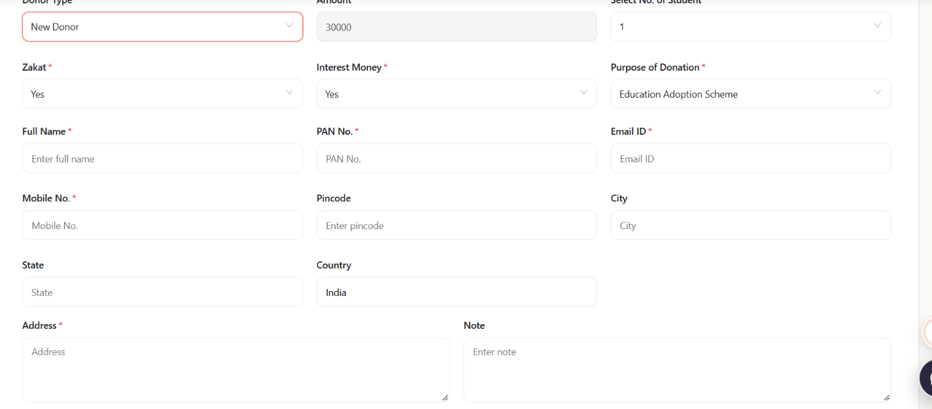
Figure 15: Donate form on the website (unchanged)
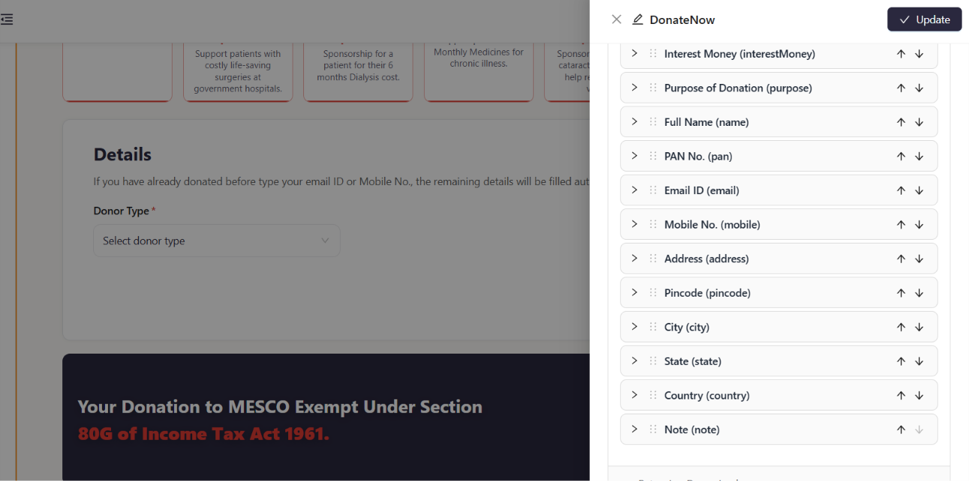
Figure 16: Form fields edited in the admin panel (DonateNow component)

ADM-04 Admin panel is too complex to use
Where: Admin → Pages, Components, Sections Type: Change Priority: High Status: Open
Tester’s note | Admin Panel is to complex something somewhere we can if it dont change and something we change it to change the component and pages sections is too complex please make it easy.
Expected result | Editing pages, sections and components should be simple for non-technical staff: clear labels, one obvious place to edit each piece of content, changes that always show on the website, and a short user guide.
Developer response

ADM-05 No deleting of records anywhere in the admin panel
Where: Admin → Submissions → Donate (and all other panels) Type: Change Priority: High Status: Open
Tester’s note | Admin Panel – Donation History - Remove the delete icon from the donation history section in the admin panel. also from all the panels we dont delete any record.
Expected result | Remove the Delete option from donation history and from every other admin panel that holds records.
Additional observation | Earlier testing found that the Editor role can also delete donation records and see donor details.
Developer response

See also: the request for one overall search bar in the admin panel is item 23 in Section 6.

4. New pages and features requested
New items to be added to the website.
NEW-01 Coffee Table Book page
Where: New page Type: New feature Priority: Medium Status: Open
Tester’s note | One new page for fully Coffee Table Book and videos and all.
Expected result | A new page showing the full Coffee Table Book, with its related videos and media.
Developer response

NEW-02 Membership button next to Volunteer
Where: Header (all pages) Type: New feature Priority: Medium Status: Open
Tester’s note | Add a Membership button next to the existing Volunteer button on the website.
Expected result | A Membership button appears beside the Volunteer button in the header on every page.
Developer response

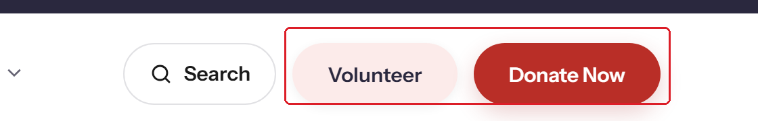
Figure 17: Header buttons today: Search, Volunteer, Donate Now

NEW-03 Career form should show only the current opening (plus one other)
Where: Get Involved → Careers → application form Type: Change Priority: Medium Status: Open
Tester’s note | Based on the current opening the form should show that role only and one other role.
Expected result | The role field of the application form lists only the role being applied for (the open position) and one other option.
Developer response

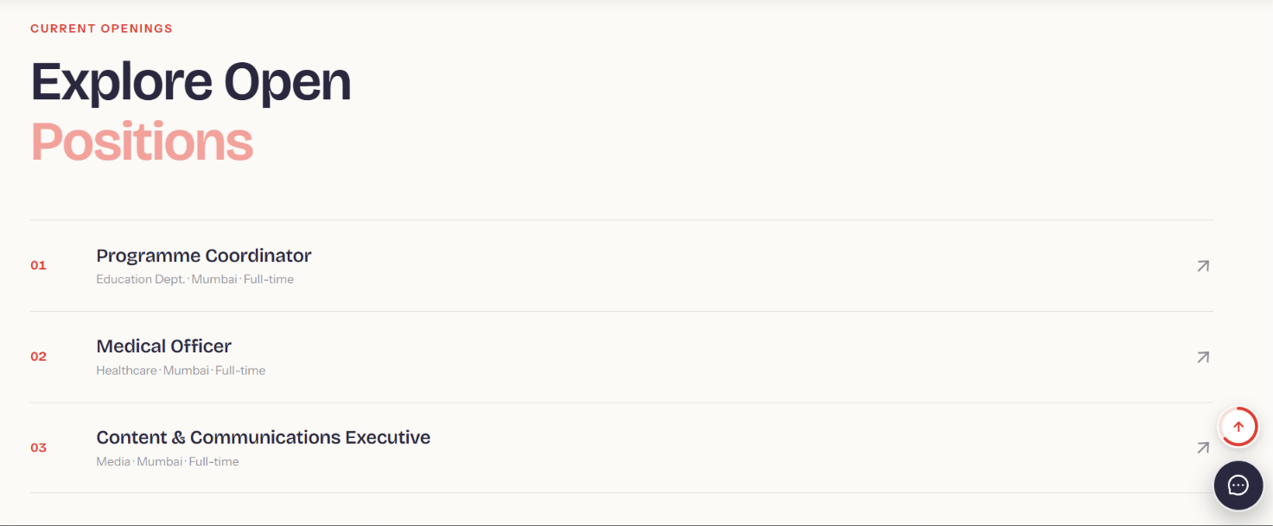
Figure 18: Current openings on the Careers page

NEW-04 FAQ section
Where: New section / page Type: New feature Priority: High Status: Open
Tester’s note | FAQ Section - Add a Frequently Asked Questions (FAQ) section to the website to provide visitors with answers to common queries about MESCO Trust, its schemes, donations, and other services.
Expected result | An FAQ page or section covering MESCO Trust, schemes, donations and services. It also meets the BRD requirement for FAQ schema (item 3 in Section 6).
Developer response

NEW-05 Ex-Student Directory page in year-wise format
Where: Media → Ex-Student Directory Type: Change Priority: Medium Status: Open
Tester’s note | Ex-Student Directory Page – Year-wise Format - Design the Ex-Student Directory page similar to the Annual Report section, with separate year-wise entries (e.g., 2025–2026). Follow the same layout and format used for the 2025–2026 Annual Report to maintain consistency across the website.
Expected result | A proper Ex-Student Directory page with one card per year, laid out like the Annual Reports page (see the figure under WEB-07). Today the menu item only opens a PDF (see WEB-01).
Developer response

NEW-06 Event attendance confirmation (Yes / No / Maybe)
Where: Events Type: New feature Priority: Low Status: Open
Tester’s note | Event Attendance Confirmation - If feasible, introduce an event attendance confirmation feature with three options: Yes, No, and Maybe, similar to calendar invitations. This will allow invitees to confirm their participation in MESCO Trust events.
Expected result | Invitees can answer Yes, No or Maybe for an event, and the admin panel shows the replies. (If feasible.)
Developer response

NEW-07 “Cause of the Month” pop-up
Where: Home page pop-up Type: New feature Priority: Low Status: Open
Tester’s note | Cause of the Month – Pop-up Feature - Explore the feasibility of introducing a “Cause of the Month” pop-up feature after the annual Charity Fest to highlight a specific cause and encourage visitor engagement and donations.
Expected result | Development team to confirm feasibility. The admin panel already has a Popups module that may be usable for this.
Developer response

5. Design, text and content review
Review notes on layout, wording and formatting. Screenshots were captured from the live site on 17 October 2026.
UI-01 MESCO logo is blurry and should be left-aligned
Where: Header (all pages) Type: Design Priority: Medium Status: Open
Tester’s note | MESCO logo on left top is blur, logo need to left aligned
Expected result | Use a high-resolution (SVG or 2x PNG) logo and align it to the left edge of the header.
Developer response

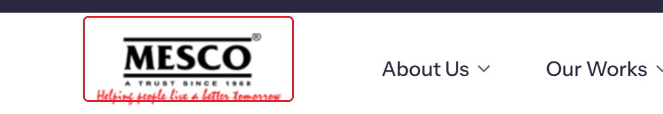
Figure 19: Header logo

UI-02 Study Centre link does not work
Where: Our Works → Study Centre Type: Bug Priority: High Status: Open
Tester’s note | Link not working - https://mescotrust.org/studycentre/
Expected result | The link should open a working Study Centre page. Today it shows “403 - Forbidden: Access is denied” (see also WEB-02).
Developer response

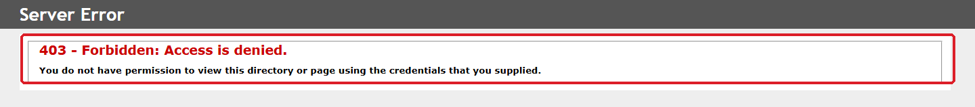
Figure 20: https://mescotrust.org/studycentre/ returns 403 Forbidden

UI-03 Body text should be justified
Where: All content pages (example: Educational Support) Type: Design Priority: Low Status: Open
Tester’s note | THe text need to formatted "Justify", Justified text gives your document better look. refer https://mesco-demo.aiolos.cloud/our-works/educational-support
Expected result | Paragraph text on content pages is justified.
Developer response

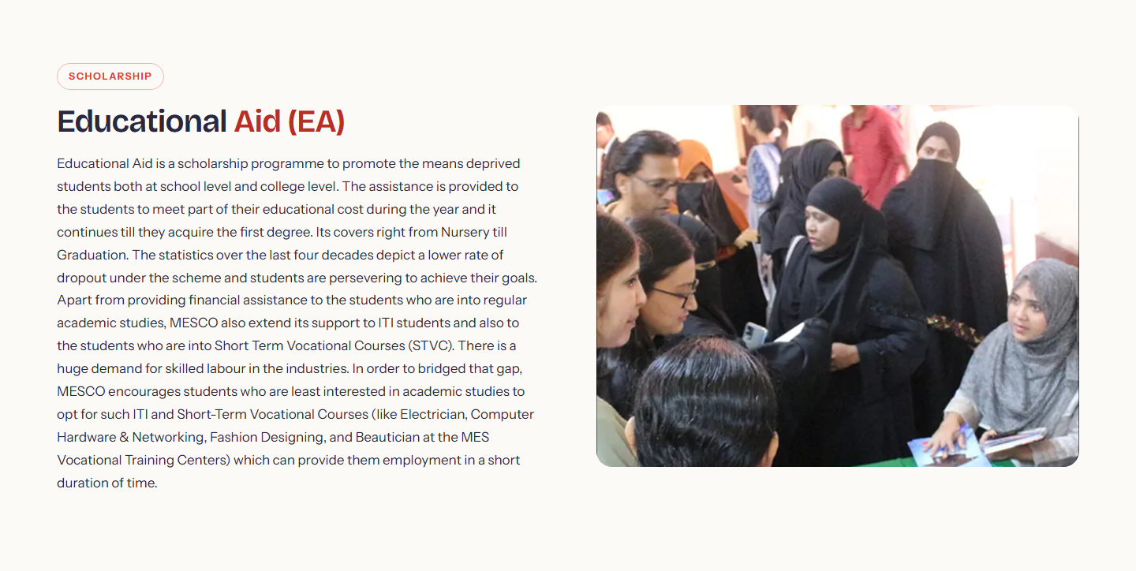
Figure 21: Educational Support page: paragraph is left-aligned, not justified

UI-04 Long paragraphs should be bulleted and easier to read
Where: Content pages Type: Design Priority: Medium Status: Open
Tester’s note | The text content to be bulleted and made more readable. The words are broken and displayed across 2 lines
Expected result | Break long paragraphs into bullet points and stop words from splitting across two lines.
Developer response

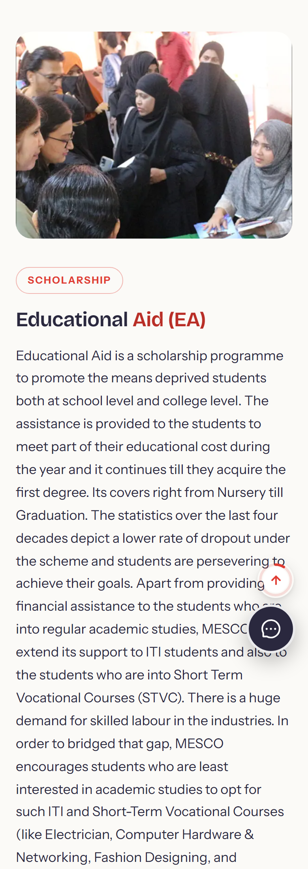
Figure 22: Example on mobile: one very long paragraph (Educational Support)

UI-05 Old Newspaper page is not well formatted
Where: https://mesco-demo.aiolos.cloud/our-works/old-newspaper-units Type: Design Priority: Medium Status: Open
Tester’s note | Page is not well formatted, fonts different. https://mesco-demo.aiolos.cloud/our-works/old-newspaper-units
Expected result | Use the same fonts and formatting as the other Our Works pages.
Additional observation | The first paragraph under “A fund-raiser at your doorstep” describes the Managing Committee, not the Old Newspaper units. It looks copied from another page.
Developer response

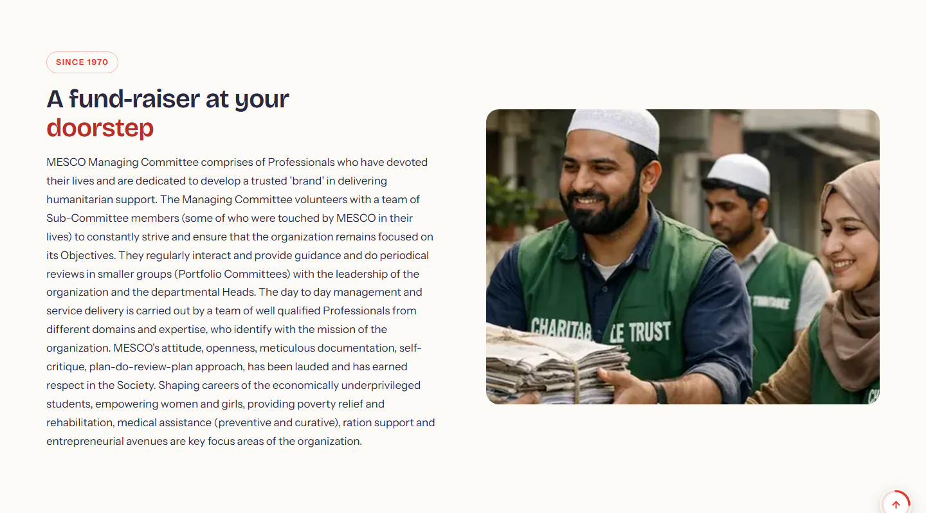
Figure 23: Old Newspaper page: the intro text is general Managing Committee text, not about the newspaper units

UI-06 Headings break onto two lines
Where: Many pages (example: Old Newspaper page) Type: Design Priority: Low Status: Open
Tester’s note | "Three units, one call away." displayed on 2 lines. there are mnay such texts.
Expected result | Short headings like “Three units, one call away.” should fit on one line on desktop. Check all similar headings.
Developer response

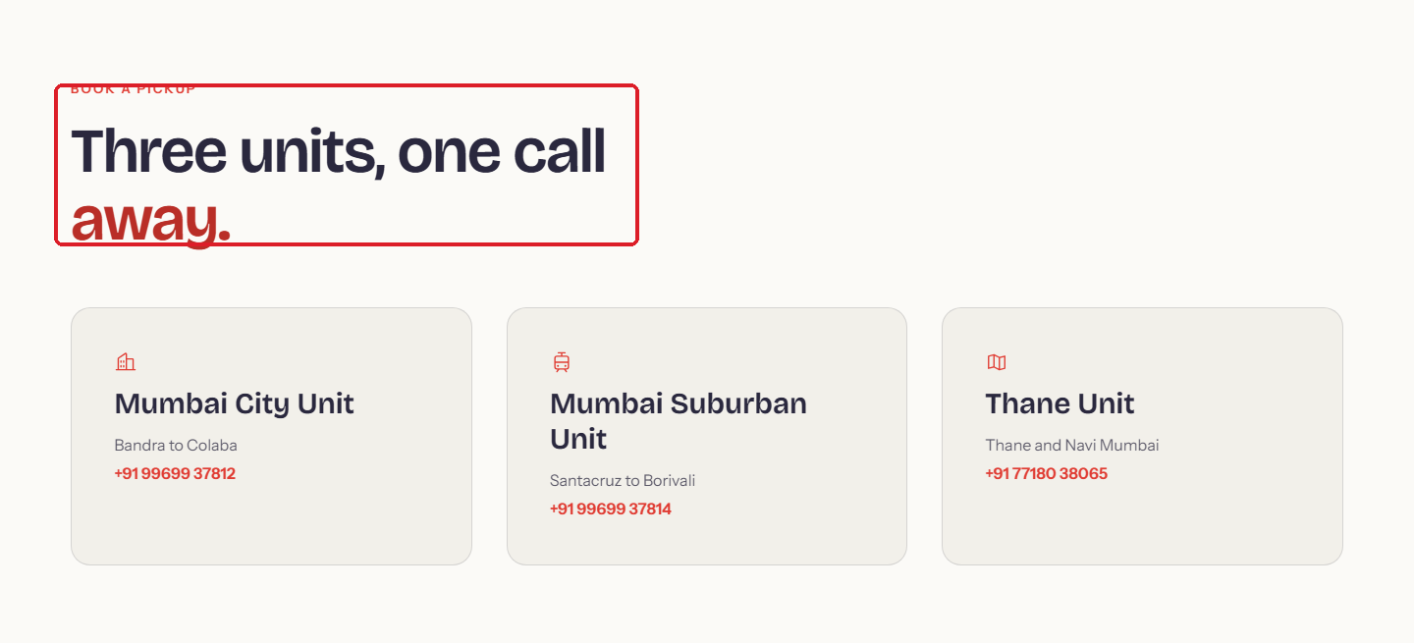
Figure 24: “Three units, one call away.” wraps onto two lines

UI-07 Button text on the Donor Testimonials page
Where: https://mesco-demo.aiolos.cloud/impact/donor-testimonials-stories Type: Content Priority: Low Status: Open
Tester’s note | page https://mesco-demo.aiolos.cloud/impact/donor-testimonials-stories.  Join them --> Donate Now ==> Become a Donor  Join them --> Become a Volunteer
Expected result | In the “Join them.” box, rename the “Donate Now” button to “Become a Donor”. Keep “Become a Volunteer”.
Developer response


Figure 25: “Join them.” box with Donate Now / Become a Volunteer buttons

UI-08 Phone numbers: format and consistency
Where: Contact Us page and footer Type: Content Priority: Medium Status: Open
Tester’s note | Contact Us page - phone number format to be corrected. also landline number is not consistent across pages .whatsapp number can be given  (+9122) 24441442, (+9122) 24448637
Expected result | Use one phone format everywhere (e.g. +91 22 2444 1442), show the same numbers on the Contact Us page and in the footer, and add a WhatsApp number.
Developer response

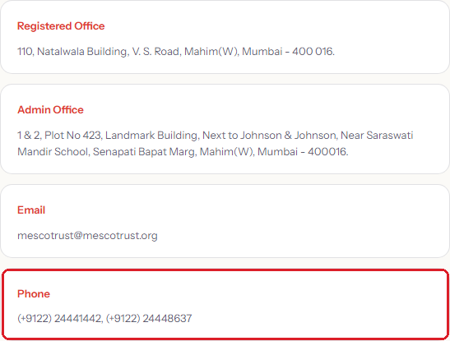 | 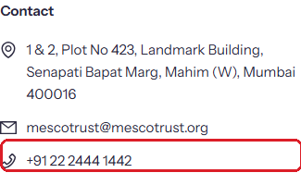
Figure 26: Contact Us page shows (+9122) 24441442, (+9122) 24448637 | Figure 27: Footer shows only +91 22 2444 1442

UI-09 Mobile menu icon has 2 lines instead of 3
Where: Header (mobile) Type: Design Priority: Low Status: Open
Tester’s note | If we see the page on mobile device, then there are 2 horizontal lines displayes , it should be 3 lines ( as per standard)
Expected result | Use the standard three-line menu (hamburger) icon on mobile.
Developer response

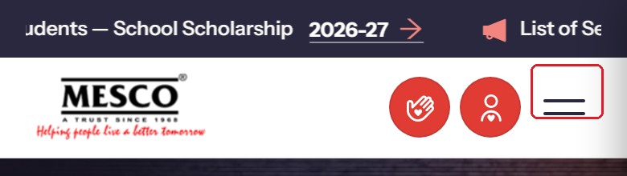
Figure 28: Mobile header: the menu icon has two lines

6. BRD gap list
Requirements from the Business Requirement Document (MESCO Website Requirement Proposal, V5) that are missing or only partly done on the demo website.

A. Missing completely (required in the BRD)
# | BRD section | BRD point | What the website has
1 | Integration | Google Analytics | Not installed. The site’s security policy would also block it from loading.
2 | Push Notifications | Browser push alerts for events, campaigns and announcements, managed from admin | Nothing, on the site or in the admin panel
3 | SEO | FAQ schema | Missing, and there’s no FAQ page
4 | SEO | Breadcrumb schema | Visible breadcrumbs exist, but not the schema search engines read
5 | Home Page | Photo Gallery | Shows “No gallery images are available”, even though the gallery page has 23 albums
6 | About Us | Our Founding Story | No page, only a one-line mention
7 | About Us | Milestones timeline | Missing create this page for us
8 | Our Work | Campaigns (create/join fundraising for causes) | No page and no module (/campaigns shows “Page not found”)
9 | Get Involved > Volunteer | SPOC / department contact details | Missing on the Volunteer page
10 | Contact Us | Department contacts (Donations, Scholarships, Volunteering) | Only the general email and phone numbers
11 | Footer | Feedback option or form | Missing

B. Partly done (something missing)
# | BRD point | What’s missing
12 | Advanced search across pages, events, news and annual reports | Search matches page titles only, with no events, blogs, news or report PDFs. “scholarship” and “zakat” return nothing.
13 | Mission & Vision | Only a section inside “MESCO At Glance”, with no separate page
14 | Our Team (Leadership, Volunteers, Advisors) | Staff and committee are listed, but there are no volunteers or advisors
15 | Testimonials under About Us | Only under Impact
16 | Work/Career (jobs and internships) | Jobs are listed, internships are not
17 | Mobile responsiveness | The home banner text and buttons are invisible on mobile at first load
18 | Security (XSS safeguards) | Found in the earlier test: a blog title or event location can inject HTML into public pages

C. Optional (“good to have”) points, none built
# | Point
19 | Donor login, donation history, receipt download and profile management.
20 | E-receipt access on the website.
21 | Alumni registration, alumni search by country, batch or profession, community and job posts, meetup tools, and alumni content sharing.
22 | Admin-side settings: push-notification and analytics settings and receipt email templates. These could not be confirmed during the admin re-check; the development team should confirm whether they exist.
23 | The admin panel should have one overall search bar to search from the full admin panel.

Appendix A. Additional findings from QA testing
Added for completeness: important findings from the earlier full QA test of the website and admin panel that are not already covered above.
# | Area | Severity | Finding
A1 | Security | Critical | Text such as </script> in a blog title or event location breaks out of the page’s structured data and injects HTML into the public page (same as BRD item 18). Fix before go-live.
A2 | Permissions | High | An Author can edit and publish any blog or event, including ones created by Admin, with no review step.
A3 | Content | High | Dummy (lorem ipsum) content is live: the only event, the blog post, one donor testimonial, the first In Media clipping and the chatbot entry “hyperlink test”.
A4 | Content | Medium | The Awards & Recognition page shows 6 identical “Credibility Alliance” cards instead of MESCO’s real awards.
A5 | Admin | Medium | No warning when leaving an unsaved page or blog; changes are lost. Saving an empty new page creates an “Untitled” page.
A6 | Social media | Medium | Instagram on the Social Wall cannot connect (saved credentials cannot be decrypted); last sync 16 Jul 2026.
A7 | SEO | Medium | Missing pages return a normal (HTTP 200) response instead of a 404 error, which can affect search ranking.
A8 | Donate | Medium | For new donors, Zakat and Interest Money both default to “Yes”, and PAN is mandatory (the BRD says optional).

Sign-off
Role | Name | Signature | Date
Prepared by (MESCO)
Reviewed by (MESCO)
Received by (Development team)

